**Feedback Control Systems**

**Lab Report 3**

**Hafiz Ahmad**

**19l-1316**

**Section-6B2**

Design of System’s Transfer Function & Response and Introduction to MATLAB SIMULINK

**INTRODUCTION:**

In order To locate the system's plots, we can make use of the transfer function. The value of the transfer function can be stored with the tf command, and the bode command can then be used to plot the bode plot graph. We can use the step command to plot the step response graph, and we can use the impulse response command. If we break down the complicated ratio into the form for which the inverse Laplace transform exists, finding it becomes simple. Using residue or tf2tp functions, which take the nominator and denominator as inputs and return the transfer function's pole, zeros, and k, we can perform partial function expansion in MATLAB. The Graphical User Interface (GUI) for MATLAB is SIMULINK. Simulink can be used to determine the response of the provided transfer function.

**OBJECTIVES:**

1. To understand the MATLAB functions used to define the transfer function and response of a system and to solve complicated polynomials.

2. To find the inverse Laplace transform and to compute partial fraction expansion of the ratio of two polynomials.

3. To understand MATLAB SIMULINK and implement system’s transfer function using it.

4. To solve the system equations and obtain the response of the system for different inputs.

**Procedure:**

In this lab, we first found the transfer functions of all of the circuits, and then we used MATLAB to plot their bode, step, and impulse graphs. Then, we used Simulink to find the response of the given transfer functions after performing partial function expansion on them.

1. **For the following circuits find Transfer Function, Identify whether it is low pass, high pass, band pass or band reject filter, Step response, Impulse response. Use 𝑅 = 3, 𝐿 = 4 𝑎𝑛𝑑 𝐶 = 2**

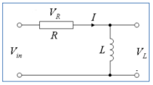

**Transfer function:**

**Q1**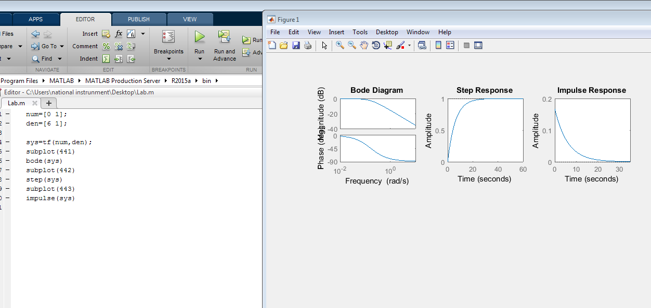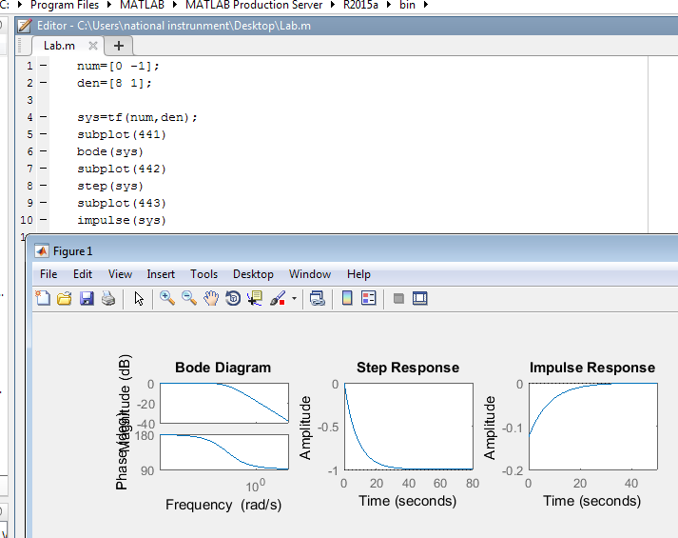

**Transfer function:**

**Graphs:**

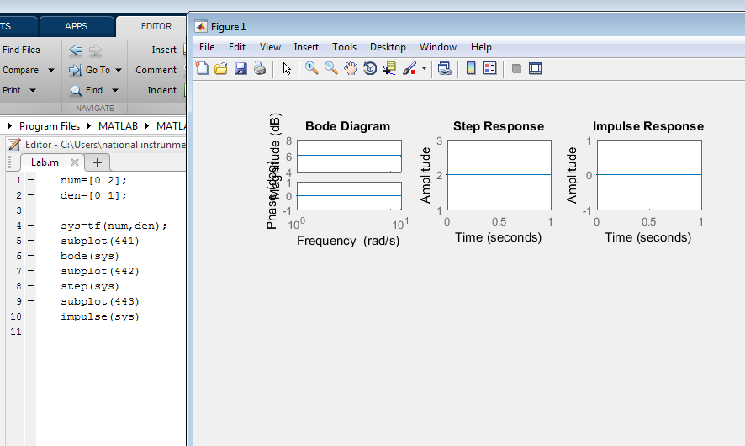

**Q3**

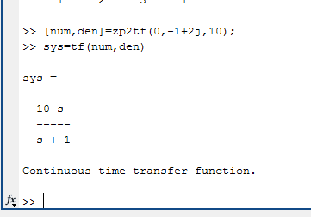

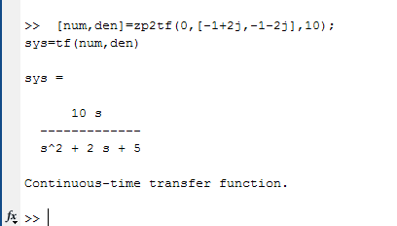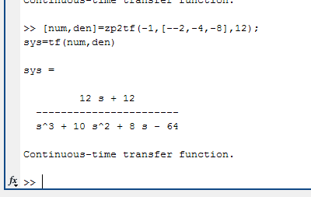

**Q4**

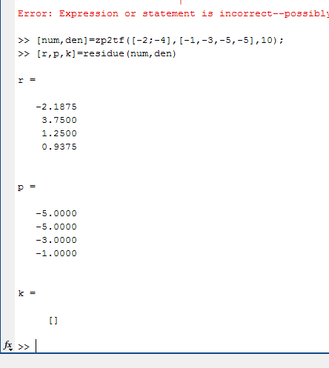

**Q5**

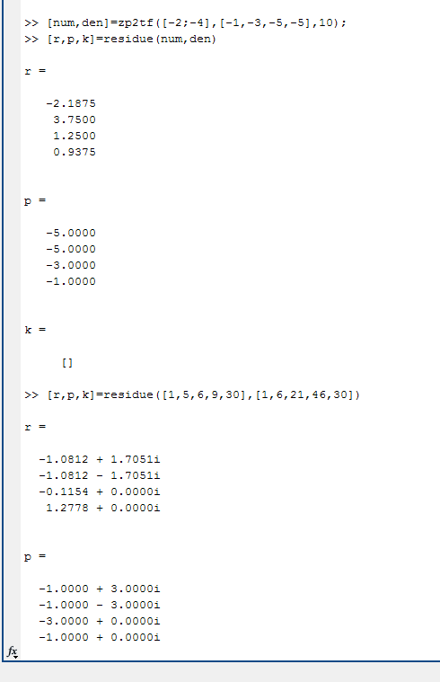

**Transfer function:**

**Graphs:**

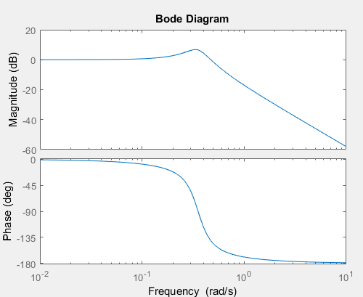

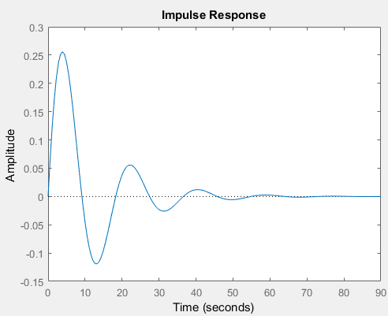

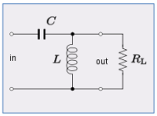

**Transfer function:**

**Graphs:**

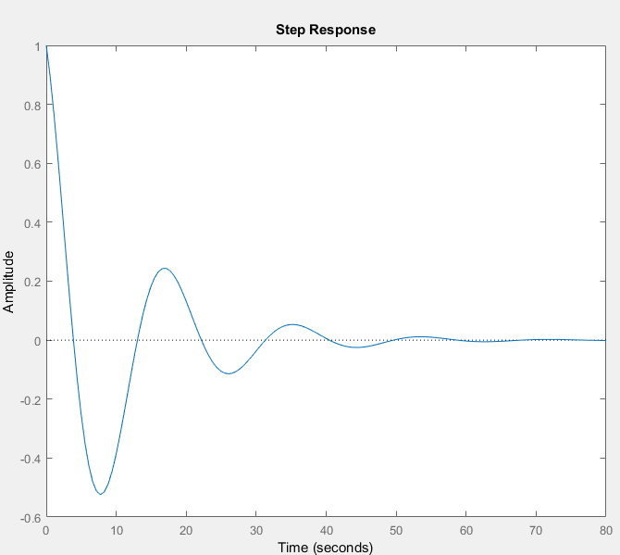

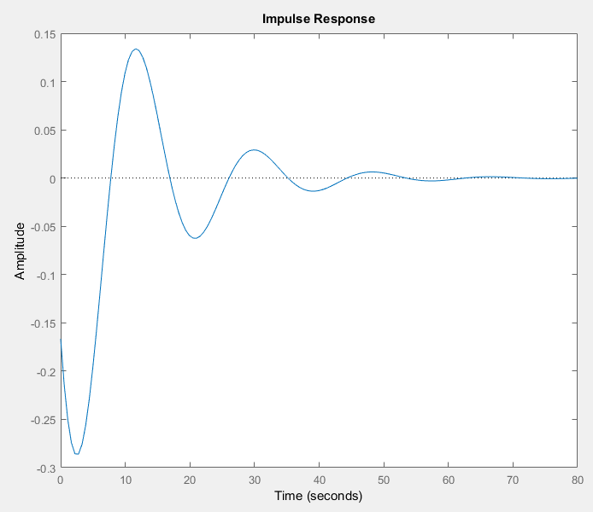

**Transfer function:**

**Graphs:**

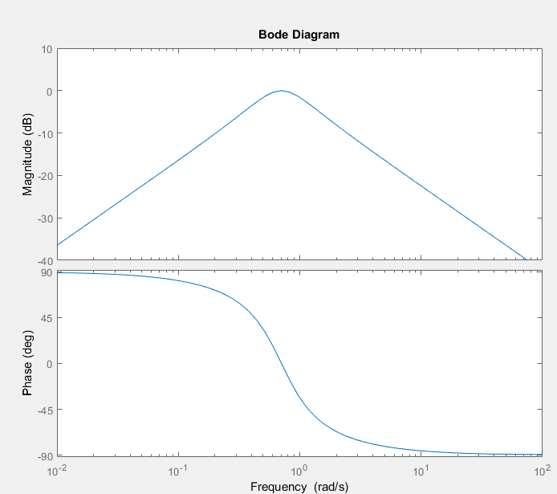

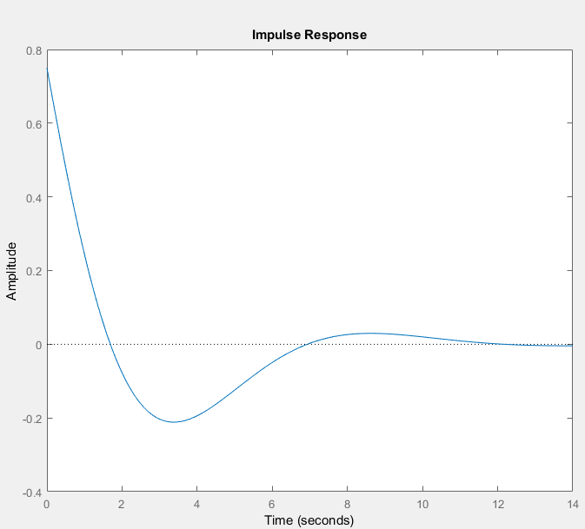

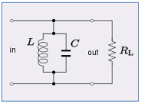

**Transfer function:**

**Graphs:**

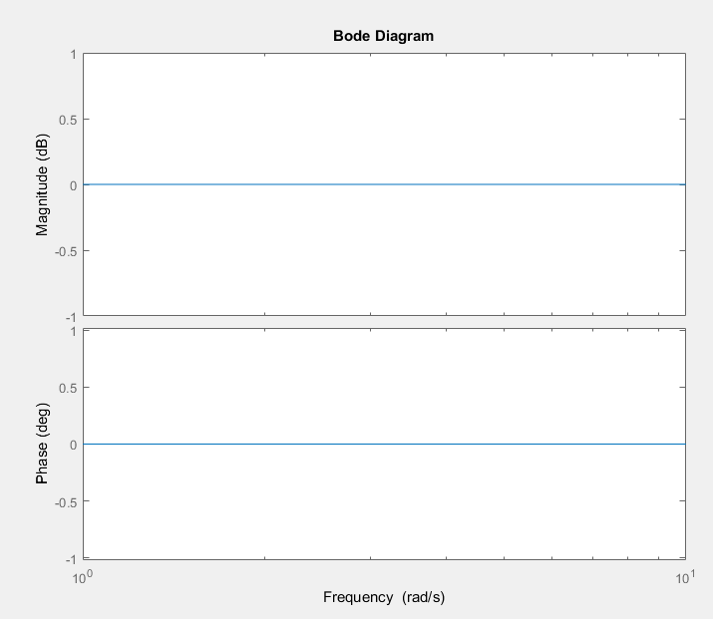 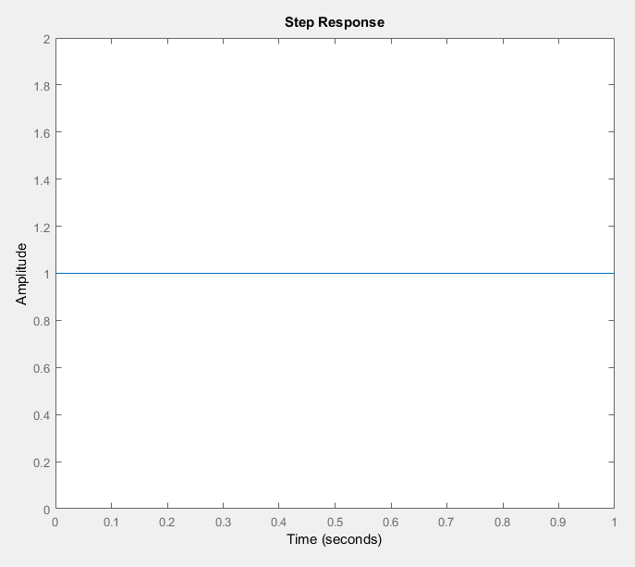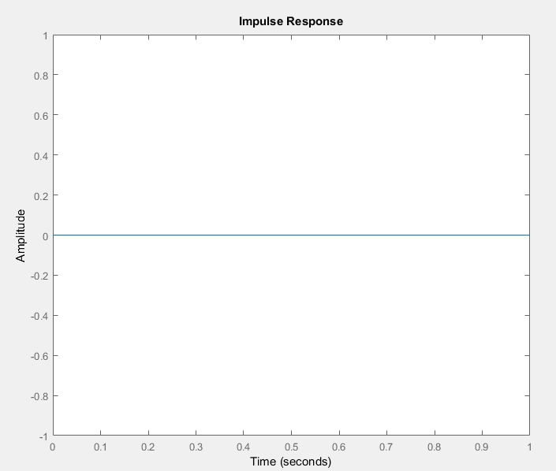

1. **For the following circuits find Transfer Function, Identify whether it is low pass, high pass, band pass or band reject filter, Step response, Impulse response Use 𝑅𝐿 = 3; 𝐿 = 4; 𝐶 = 2; 𝑅1 = 𝑅2 = 4; 𝑅3 = 2; 𝑅4 = 4**

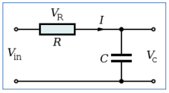

**Transfer function:**

**Graphs:**

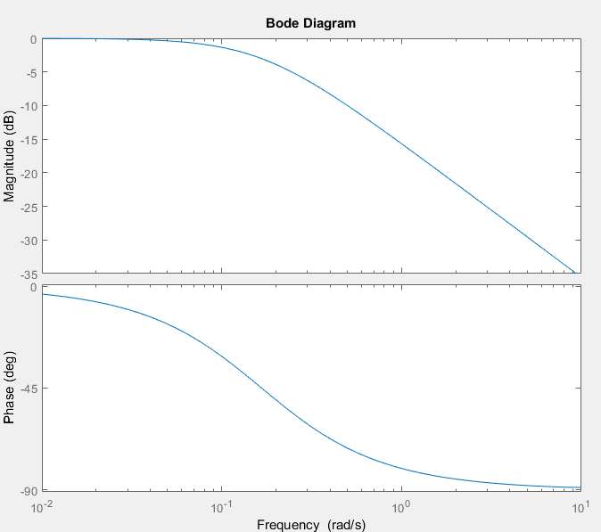 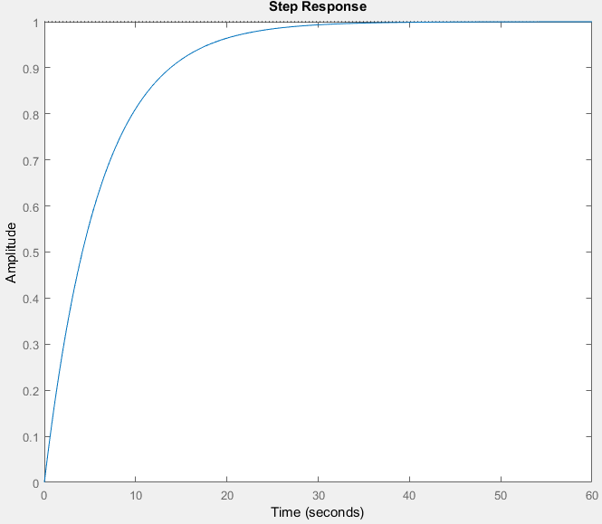

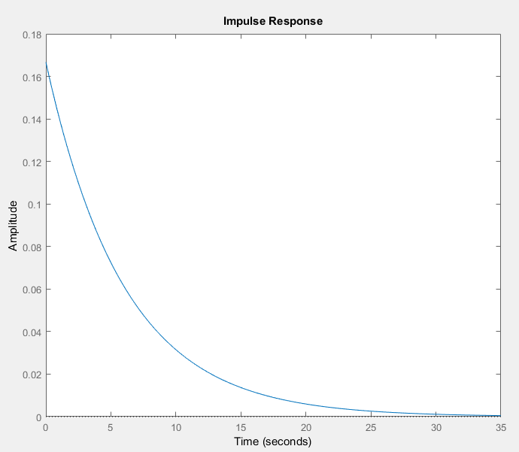

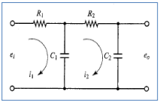

**Transfer function:**

**Graphs:**

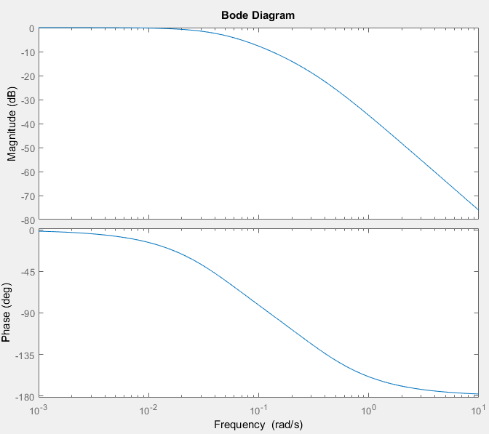 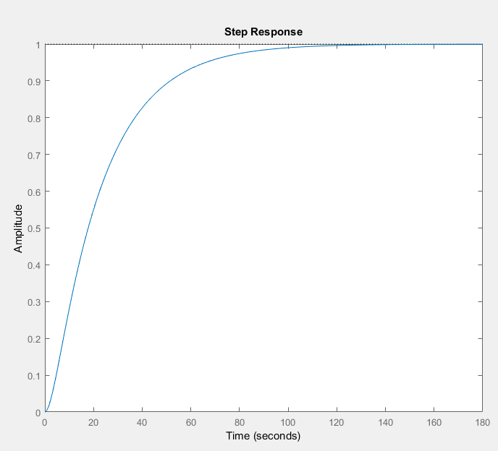

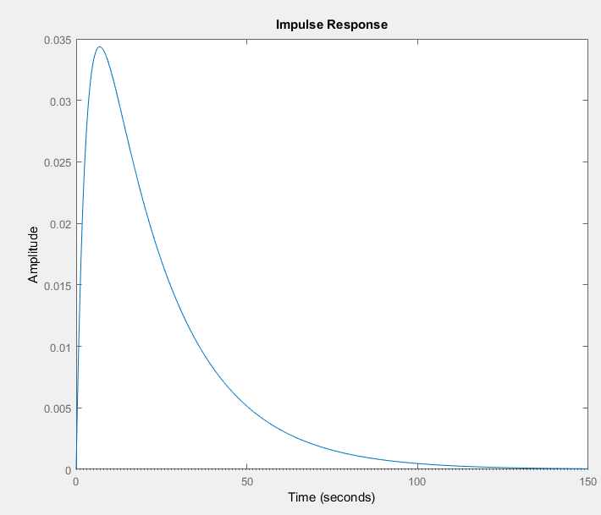

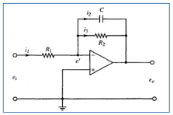

**Transfer function:**

**Graph:**

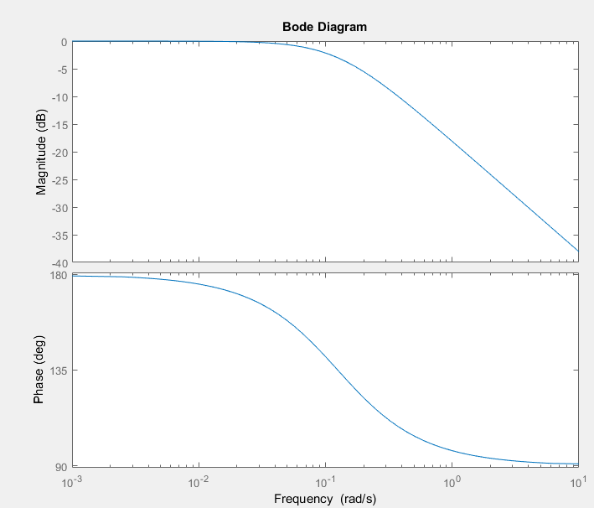 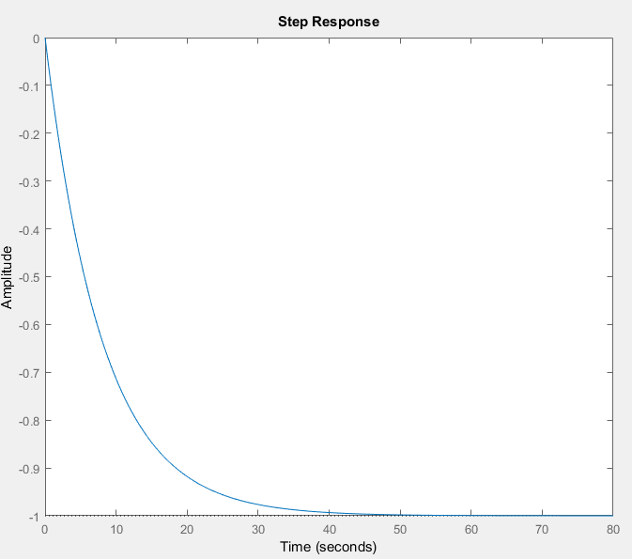

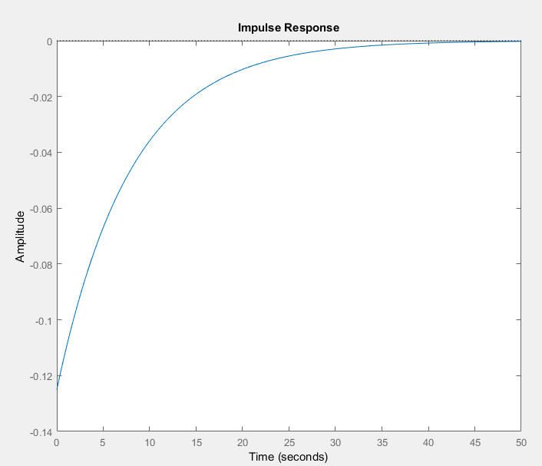

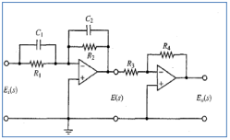

**Transfer function:**

**Bode plot:**

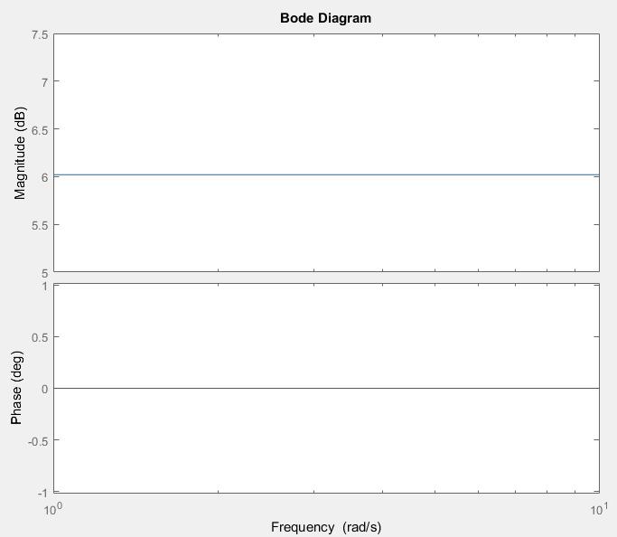 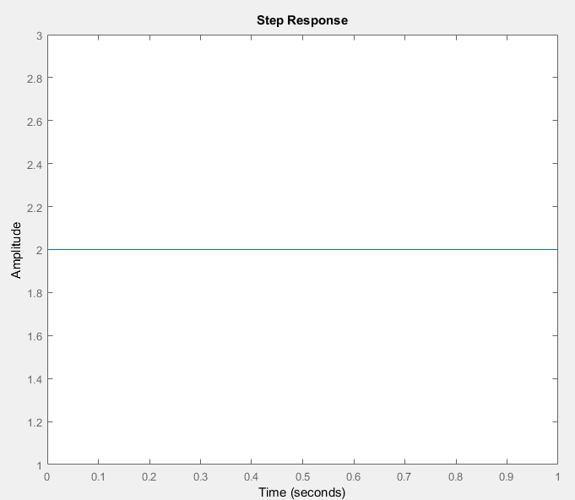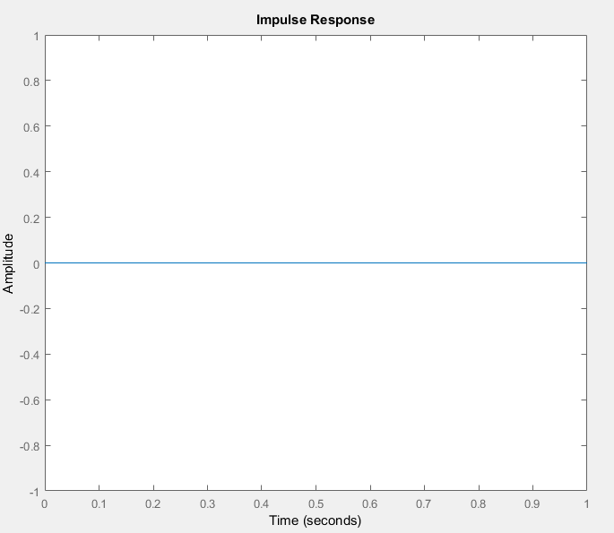

**Transfer function:**

**Bode plot:**

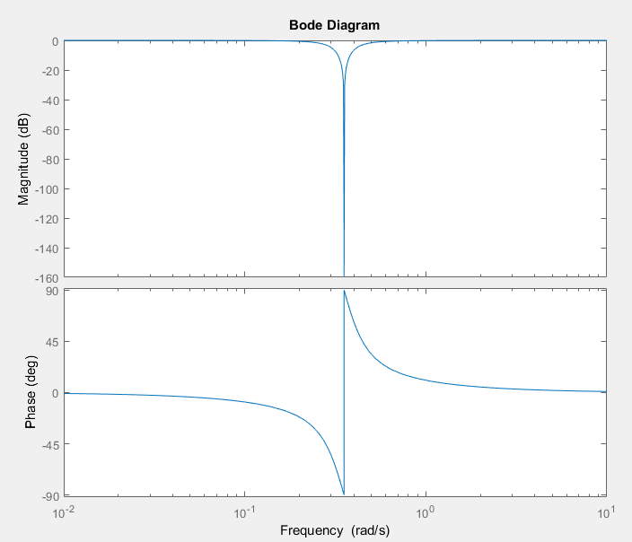 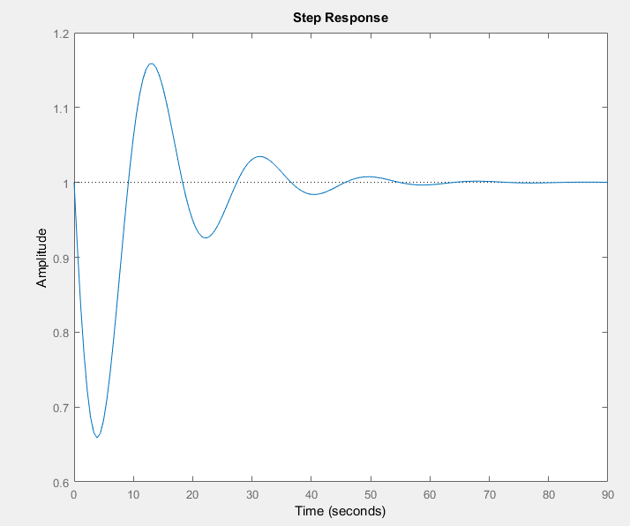

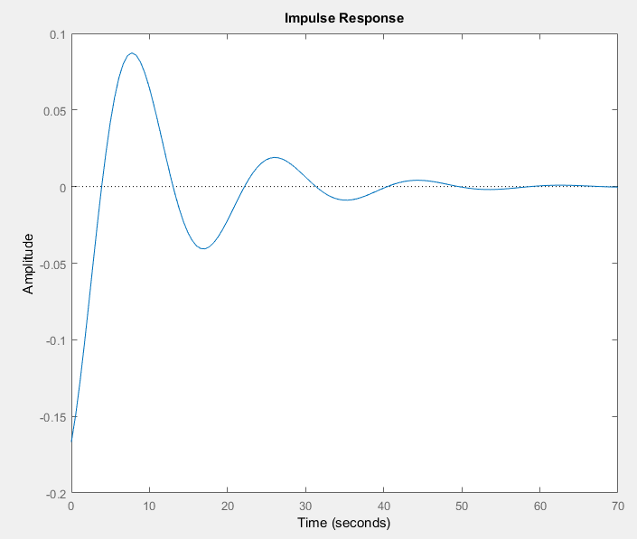

***Patrial function expansion***

**Exercise 1: Obtain the inverse Laplace transform of the following F(s). [Use MATLAB to find the partial fraction expansion of F(s)]. Write the inverse Laplace transform in the text box below**



**Code:**



**Output:**

**Transform:**

**=**

**Exercise 2: Given the zero(s), pole(s), and gain K of B(s)/A(s), obtain the function B(s)/A(s) using MATLAB. Consider the three cases below. Write the transfer function of each in the text box below:**

**• There is no zero. Poles are at -1+2j and -1-2j, K=10**

**Code:**



**Transfer Function:**

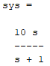

**• A zero is at 0. Poles are at -1+2j and -1-2j, K=10**

**Code:**



**Transfer function:**

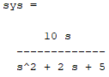

**• A zero is at -1. Poles are at -2,-4and -8. K=12.**

**Code:**



**Transfer function:**

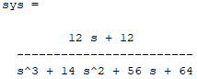

**Exercise 3: A function B(s)/A(s) consists of the following zeros, poles, and gain K:**

**• Zeros at s=-1, s=-2**

**• Poles at s=0, s=-4, s=-6**

**• Gain K=5 Obtain the expression for B(s)/A(s) = num /den with MATLAB and write it in the space below:**

**Code:**



**Transfer function:**

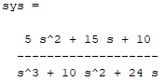

**Exercise 4: Obtain the partial fraction expansion of the following function with MATLAB:**



**Then, obtain the inverse Laplace transform of F(s). Write the inverse Laplace transform in the space below:**

**Code:**



**Output:**

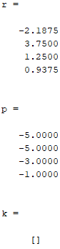

**Transform:**

**=**

**Exercise 5: Consider the following function F(s):**



**Using MATLAB, obtain the partial fraction expansion of F(s). Then, obtain the inverse Laplace transform of F(s) and write it in the box below:**

**Code:**



**Output:**

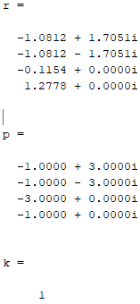

**Transform:**

**=(1.7051i−1.0812)(ie6tre(i)sin(3tim(i))+e6tre(i)cos(3tim(i))+isin(3tim(i))−cos(3tim(i)))e−t(3re(i)+1)-0.1154e-3t+1.2778e-t**

***Simulink:***

**Exercise 1: Generate the following MATLAB SIMULINK model in Figure 3.11 and simulate its step response.**

**Circuit:**

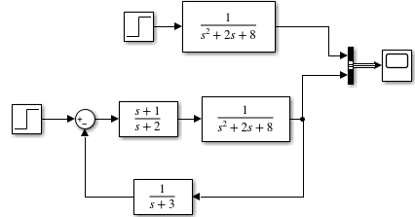

**Output:**

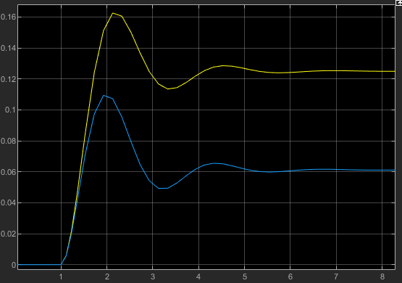

**Exercise 2: a. Obtain the unit impulse response of the following system using SIMULINK.**



**Circuit:**

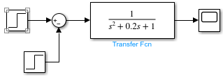

**Output:**

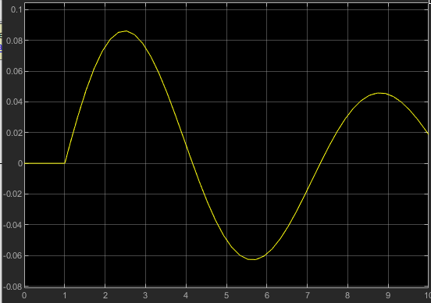

**b. Obtain the unit step response of the following system using SIMULINK.**



**Circuit:**



**Output:**

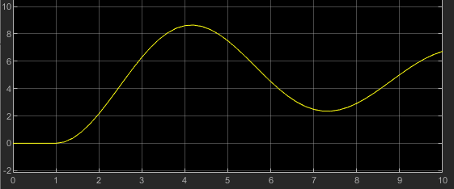

**Explain why the results in ‘a’ and ‘b’ are same.**

**Ans: The results of both the graphs are same because they are the step and impulse response of the second order system.**

**Application:**

By doing this experiment A transfer function is a convenient way to represent a linear, time-invariant system in terms of its input-output relationship. It is obtained by applying a Laplace transform to the differential equations describing system dynamics, assuming zero initial conditions. Transfer functions for components are used to design and analyze systems assembled from components, particularly using the block diagram technique, in electronics and control theory. The dimensions and units of the transfer function model the output response of the device for a range of possible inputs.

**Issues:**

No issue found while performing the lab.

**Conclusion:**

In this lab we learn the following:

1. to solve difficult polynomials and comprehend the MATLAB functions used to define a system's transfer function and response.

2. to compute the partial fraction expansion of the ratio of two polynomials and to locate the inverse Laplace transform.

3. to comprehend MATLAB SIMULINK and use it to carry out the system's transfer function.

4. to find the system's response for various inputs and solve the system's equations.

**Post lab:**

Question 1: Solve the following differential equation using MATLAB: 𝒙̈+ 𝟐𝒙̇ + 𝟏𝟎𝒙 = 𝒆 −𝒕 , 𝒙(𝟎) = 𝟎, 𝒙̇(𝟎) = 𝟎 The function e -t is given at t=0 when the system is at rest.

=> 𝒙̈=1

=>x=t^2

Question 2: Find the transfer function of following circuit shown in Figure

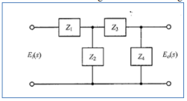

Ans:

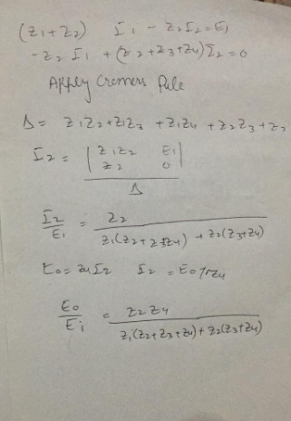

Question 3: a) How can LTI filters be uniquely identified by their impulse response?

Ans: Any LTI system can be completely characterized by a single function, known as the system's impulse response, according to LTI system theory. Simply combining the system's impulse response h(t) with the input to the system x(t) creates the output of the system y(t).

b) How can you identify the order of a system from its differential equation?

Ans: The highest derivative in a differential equation determines the equation's order.

c) How can Laplace transform offer a convenient method for the solution of linear, time-invariant differential equations?

Ans: When Laplace transforms a differential equation into an algebraic problem, the initial value is taken care of during the algebraic manipulations. In the end, after resolving the algebraic problem, we use the inverse Laplace transform to precisely determine what we wanted.

Question 4: Create a SIMULINK model with a first order system, with gain, K =1, and time constant, T = 0.1 sec. Simulate a square wave input with unit amplitude and frequency of 0.3 Hz. The sample time is 0.001 sec. View the reference position, xr(t), input, u(t), and actual position, x(t), through a scope, as in Figure below. Experiment with different values of Kp and observe how the system response changes. Plot the results.

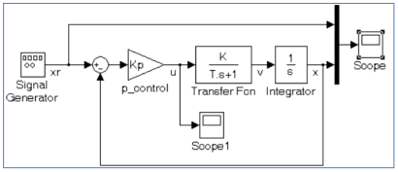

Outputs:

When K=1

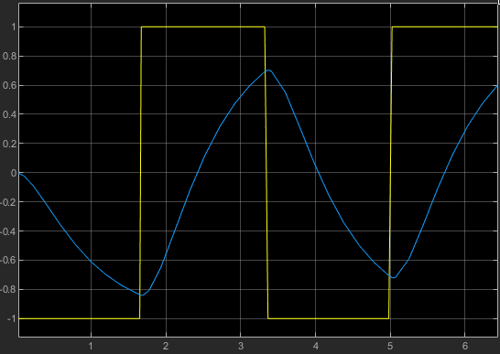

When k=2

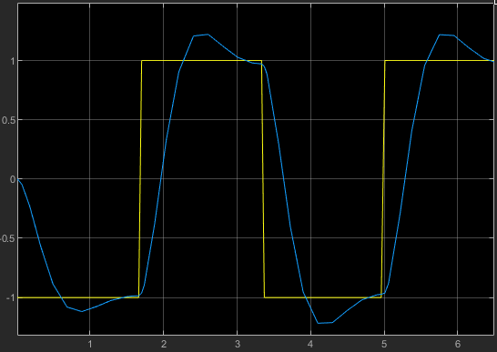 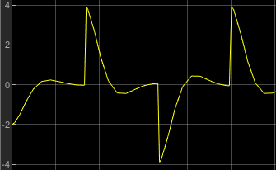

When K=3

